Introggplot

Ryan

September 28, 2015

## Install the packages first

#install.packages(c("ggplot2","RColorBrewer","ggthemes","gridExtra"))  
library(ggplot2)  
require(RColorBrewer)  
library(ggthemes)  
require(gridExtra)

## A first plot

The diamonds dataset come with ggplot2 package and often used to show examples of ggplot2  
Don't worry everything will be clear to you very soon

data(diamonds)  
qplot(data = diamonds, x = carat, y = price, color = cut, alpha = 0.1) +   
 scale_color_brewer(palette = "Spectral") +   
 theme_minimal()

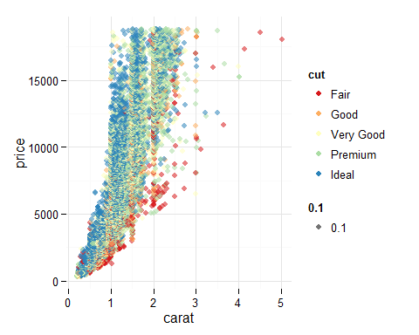

## Variables in the diamonds dataset

str(diamonds)

## 'data.frame': 53940 obs. of 10 variables:  
## $ carat : num 0.23 0.21 0.23 0.29 0.31 0.24 0.24 0.26 0.22 0.23 ...  
## $ cut : Ord.factor w/ 5 levels "Fair"<"Good"<..: 5 4 2 4 2 3 3 3 1 3 ...  
## $ color : Ord.factor w/ 7 levels "D"<"E"<"F"<"G"<..: 2 2 2 6 7 7 6 5 2 5 ...  
## $ clarity: Ord.factor w/ 8 levels "I1"<"SI2"<"SI1"<..: 2 3 5 4 2 6 7 3 4 5 ...  
## $ depth : num 61.5 59.8 56.9 62.4 63.3 62.8 62.3 61.9 65.1 59.4 ...  
## $ table : num 55 61 65 58 58 57 57 55 61 61 ...  
## $ price : int 326 326 327 334 335 336 336 337 337 338 ...  
## $ x : num 3.95 3.89 4.05 4.2 4.34 3.94 3.95 4.07 3.87 4 ...  
## $ y : num 3.98 3.84 4.07 4.23 4.35 3.96 3.98 4.11 3.78 4.05 ...  
## $ z : num 2.43 2.31 2.31 2.63 2.75 2.48 2.47 2.53 2.49 2.39 ...

## qplot()

Histogram using qplot() function  
qplot() is one plotting function in ggplot, the other one is ggplot()  
ggplot() syntax is more difficult to understand  
We will start with

qplot(x = price, data = diamonds)

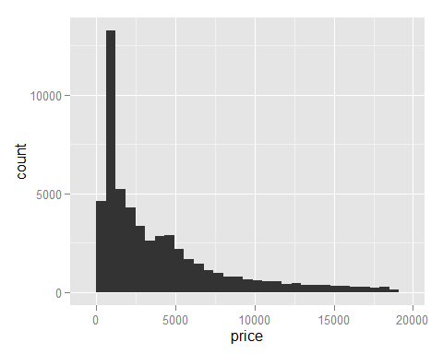

## Alter the look using themes in ggthemes package

Try different themes

qplot(x = price, data = diamonds) + theme_economist()

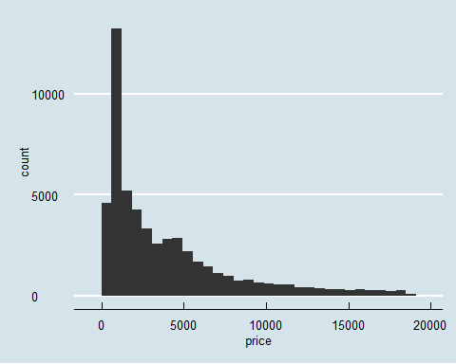

## Setting default theme

Set once, use through out the file

theme_set(theme_minimal(11))  
qplot(x = color, data = diamonds)

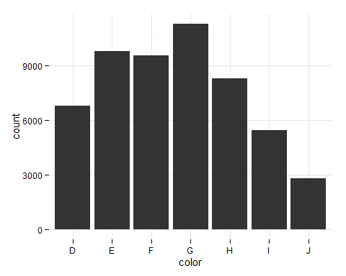

## Introducing color

try #099DD9 here [w3School color picker](http://www.w3schools.com/tags/ref_colorpicker.asp) It is light blue  
Let's use color name and the hex code

qplot(x = price, data = diamonds, color = 'black', fill = '#099DD9')

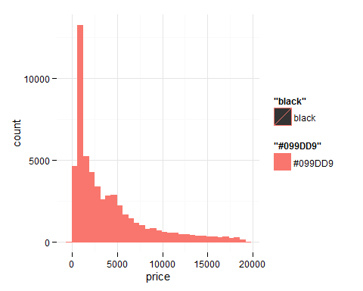

What's wrong...?  
ggplot does not treat 'black' and '#099DD9' in default, to force ggplot to treat them as colors, use I() the 'as is' function

qplot(x = price, data = diamonds, color = I('black'), fill = I('#099DD9'))

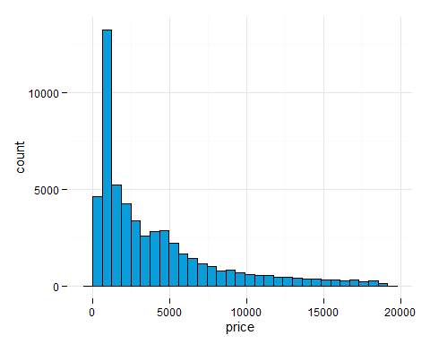

## Change the axis labels

qplot(x = price, data = diamonds, color = I('black'), fill = I('#099DD9'),   
 xlab = "diamond price", ylab = 'frequency')

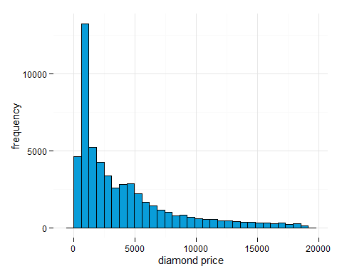

## Facet wrap

Use facet wrap to create a series of plot on subset of the data  
This is equivlent to subset the dataframe using color, and plot histograms for each subset

qplot(x = price, data = diamonds) +   
 facet_wrap(~color, ncol = 4)

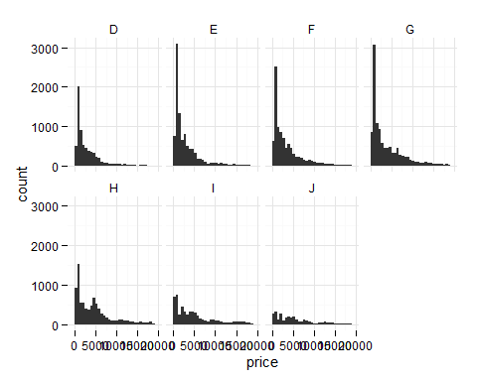

## Facet grid

Use facet grid to explore subset according to combinations of two variables

qplot(x = price, data = diamonds) +   
 facet_grid(color~cut)

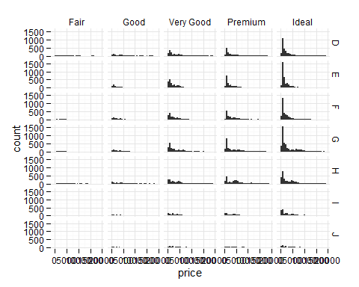

## Adjust axes

Let's look at the measure that really matters....

qplot(x = carat, data = diamonds)

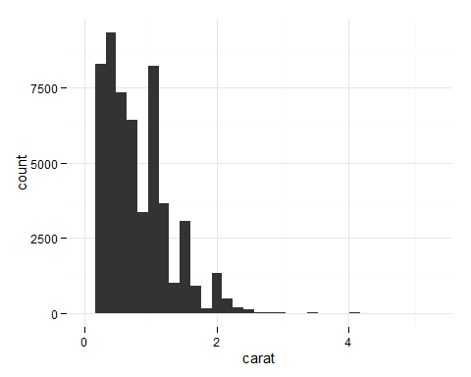

What if... I am only interested in the BIG diamonds?  
Subsetting is ofcourse a way to do it

qplot(x = carat, data = diamonds[diamonds$carat > 2,])

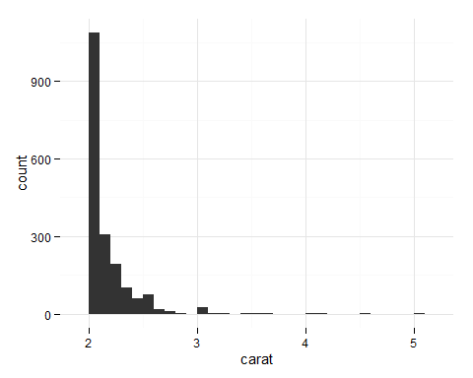

Or do it using a more ggplot way

qplot(x = carat, data = diamonds) +   
 scale_x_continuous(limits = c(2,max(diamonds$carat)))

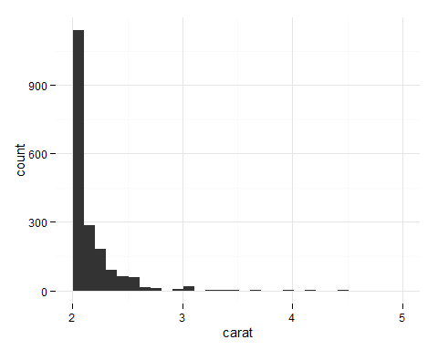

## Setting binwidth

to set binwidth, use breaks()

qplot(x = carat, data = diamonds, binwidth = 0.01) +   
 scale_x_continuous(limits = c(0.3,0.5))

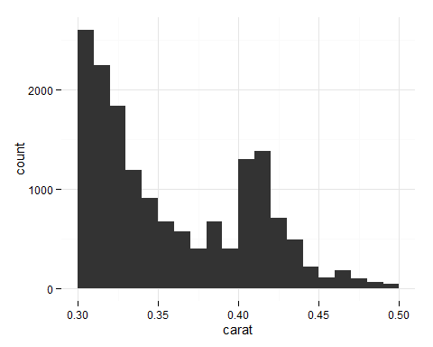

What is a good binwidht?

qplot(x = carat, data = diamonds, binwidth = 0.1) +   
 scale_x_continuous(limits = c(0.3,0.5))

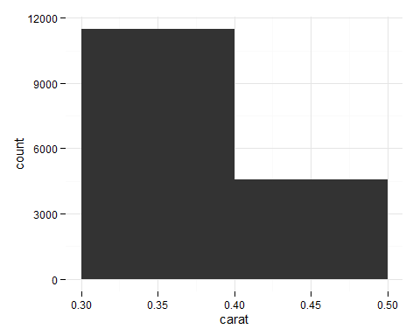

## Layer on layer

The natural way to think about ggplot is adding layers to the existing plots to modify behavior

qplot(x = carat, data = diamonds, binwidth = 0.25) +   
 scale_x_continuous(limits = c(0.25,1.5)) +   
 facet_wrap(~cut, ncol = length(levels(diamonds$cut)))

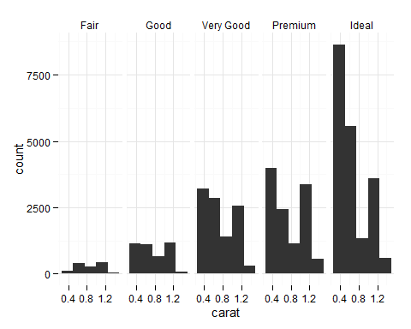

## Transformation

Originally low tail distributed data

qplot(x = price, data = diamonds)

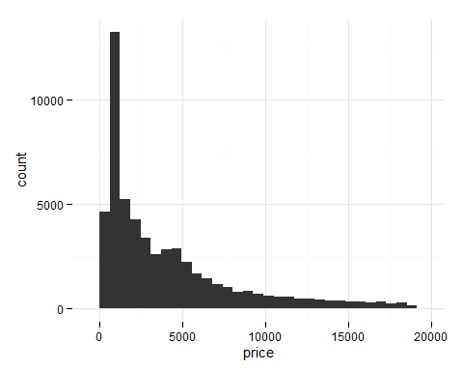

Log transformation

qplot(x = log(price + 0.000001), data = diamonds)

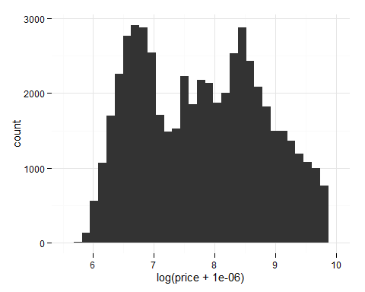

Save plot into a variable and then use gridExtra to show multiple plots

p1 <- qplot(x = price, data = diamonds)  
p2 <- qplot(x = log(price), data = diamonds)  
p3 <- qplot(x = sqrt(price), data = diamonds)  
grid.arrange(p1,p2,p3,ncol = 1, nrow = 3)

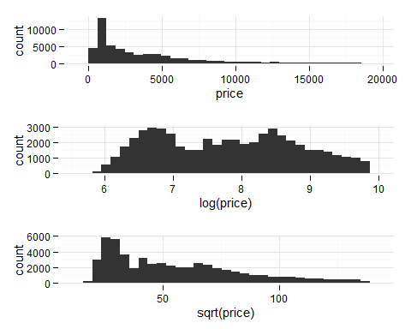

Actually... more ggplot way of doing this is.....  
Add a layer!

p2 <- qplot(x = price, data = diamonds) + scale_x_log10()  
p3 <- qplot(x = price, data = diamonds) + scale_x_sqrt()  
grid.arrange(p1,p2,p3,ncol = 3, nrow = 1)

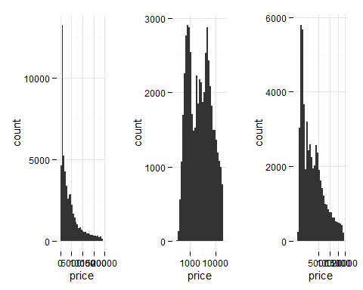

## Introducing the goem

Tired of histograms....? Me too  
Let's look at different geoms

pcut <- qplot(x = price, data = diamonds, geom = 'freqpoly', color = cut)  
pcolor <- qplot(x = price, data = diamonds, geom = 'freqpoly', color = color)  
pclarity <- qplot(x = price, data = diamonds, geom = 'freqpoly', color = clarity)  
grid.arrange(pcut, pcolor, pclarity, nrow =3 )

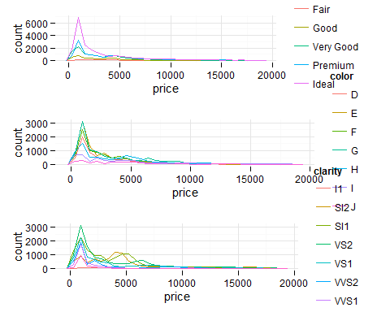

almost look like CDFs, except the y axis...  
warning!!! strange looking code ahead...

pcut <- qplot(x = price, y = ..count../sum(..count..), data = diamonds, geom = 'freqpoly', color = cut, ylab = 'probability')  
pcolor <- qplot(x = price, y = ..count../sum(..count..), data = diamonds, geom = 'freqpoly', color = color, ylab = 'probability')  
pclarity <- qplot(x = price, y = ..count../sum(..count..), data = diamonds, geom = 'freqpoly', color = clarity, ylab = 'probability')  
grid.arrange(pcut, pcolor, pclarity, nrow =3 )

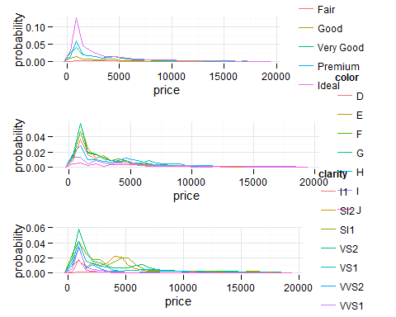

## Box plots

Or this is to test if you need a new laptop or not...

qplot(x = cut, y = price, data = diamonds, geom = 'boxplot') +   
 facet_grid(color~clarity)

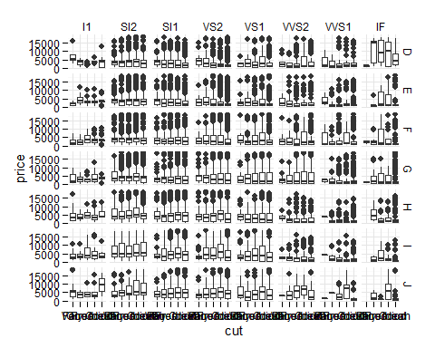

## Scatter plot

Regression works?

qplot(x = carat, y = price, data = diamonds)

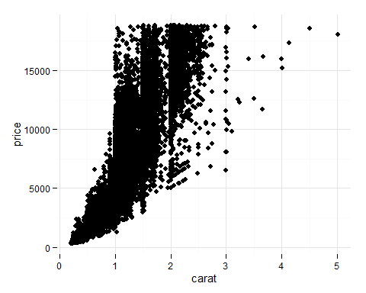

## We should start using ggplot() function now

This is equvalent to the qplot() function we been using until now  
But this syntax show the layer on top of layer concept in ggplot more clearly

ggplot(aes(x= carat, y = price), data = diamonds) +   
 geom_point()



## Add some transparency

ggplot(aes(x= carat , y = price), data = diamonds) +   
 geom_point(alpha = 0.05)

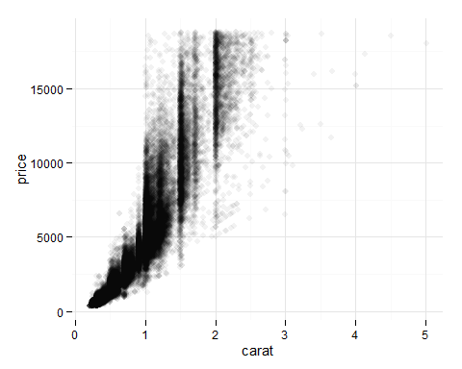

## Add jitter

Trying to find a case to show the need for this....  
But maybe not so good with this dataset

p1 <- ggplot(aes(x= table , y = price), data = diamonds) +   
 geom_point(alpha = 0.1) +   
 xlim(55,60)  
p2 <- ggplot(aes(x= table , y = price), data = diamonds) +   
 geom_jitter(alpha = 0.1) +  
 xlim(55,60)  
grid.arrange(p1,p2, ncol = 2)

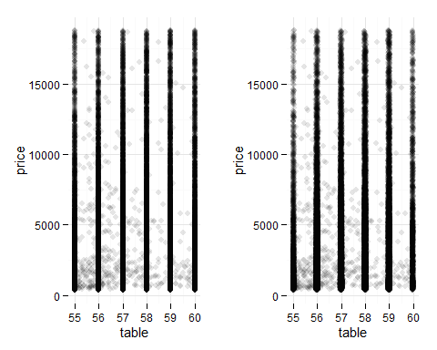

## Transform using layer

ggplot(aes(x= carat , y = price), data = diamonds) +   
 geom_point(alpha = 0.05) +   
 coord_trans( y = 'sqrt' ) +   
 xlim(0,3)

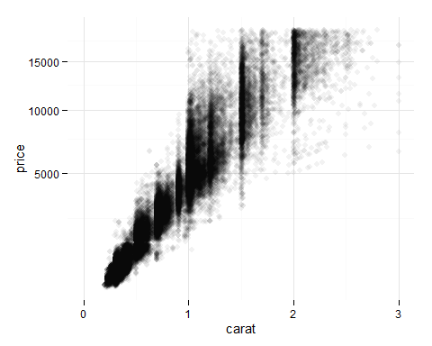

## Conditional Mean

ggplot(aes(x= carat , y = price), data = diamonds) +   
 geom_point(alpha = 0.05, color = I('#60DFE5')) +   
 coord_trans( y = 'sqrt' ) +   
 xlim(0,3) +   
 geom_line(stat = 'summary', fun.y = mean)

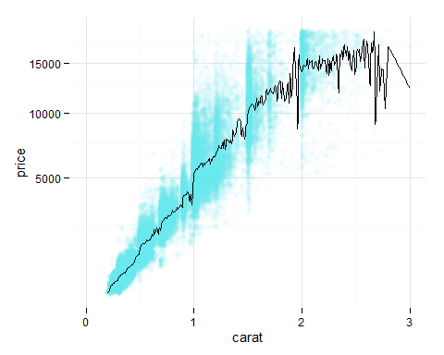

## Quantiles as well

ggplot(aes(x= carat , y = price), data = diamonds) +   
 geom_point(alpha = 0.05, color = I('#60DFE5')) +   
 coord_trans( y = 'sqrt' ) +   
 xlim(0,3) +   
 geom_line(size = 1, stat = 'summary', fun.y = mean) +   
 geom_line(siz3 = 1, linetype = 2, stat = 'summary', fun.y = quantile, probs = 0.25) +   
 geom_line(size = 1, linetype = 2, stat = 'summary', fun.y = quantile, probs = 0.75)

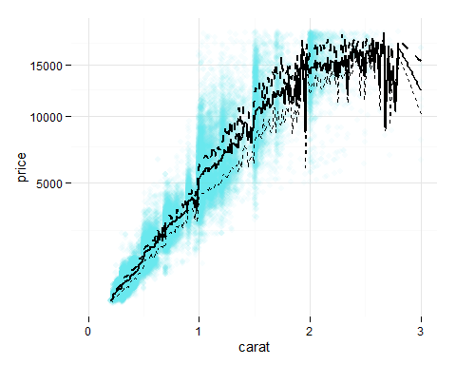

## Smoothed Conditional Mean

ggplot(aes(x= carat , y = price), data = diamonds) +   
 geom_point(alpha = 0.08, color = I('#60DFE5')) +   
 xlim(0,3.5) +   
 stat_smooth(method = "gam" , color = I('blue'))

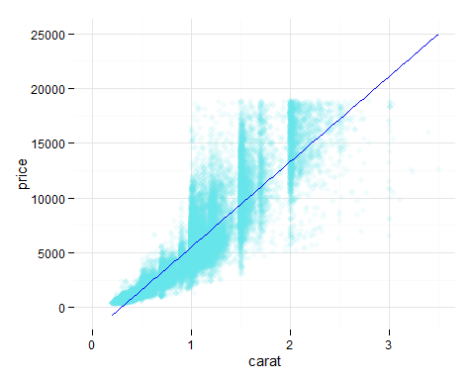

## Some stats by hand

model <- lm(price~carat, data = diamonds)  
linspace <- seq(0, 3.5, 0.01)  
ci <- predict(model, data.frame(carat = linspace), interval = "confidence", level = 0.999)  
pi <- predict(model, data.frame(carat = linspace), interval = "prediction", level = 0.999)  
mu_hat <- ci[,1]

## Explain?....

ggplot(aes(x= carat , y = price), data = diamonds) +   
 geom_point(alpha = 0.08, color = I('#60DFE5')) +   
 geom_line(data = data.frame(carat = linspace, price = ci[,2]), color = 'red') +   
 geom_line(data = data.frame(carat = linspace, price = ci[,3]), color = 'red') +  
 geom_line(data = data.frame(carat = linspace, price = pi[,2]), color = 'blue') +  
 geom_line(data = data.frame(carat = linspace, price = pi[,3]), color = 'blue') +  
 geom_line(data = data.frame(carat = linspace, price = mu_hat), color = 'black')

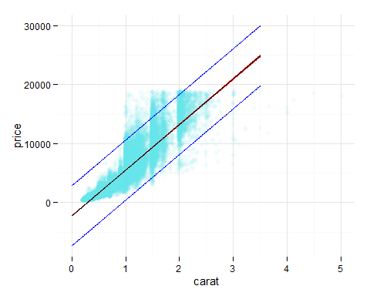

## Some Plots I did in the past

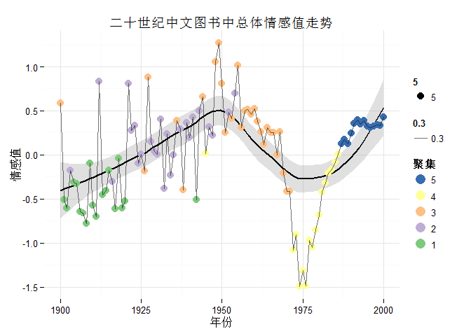

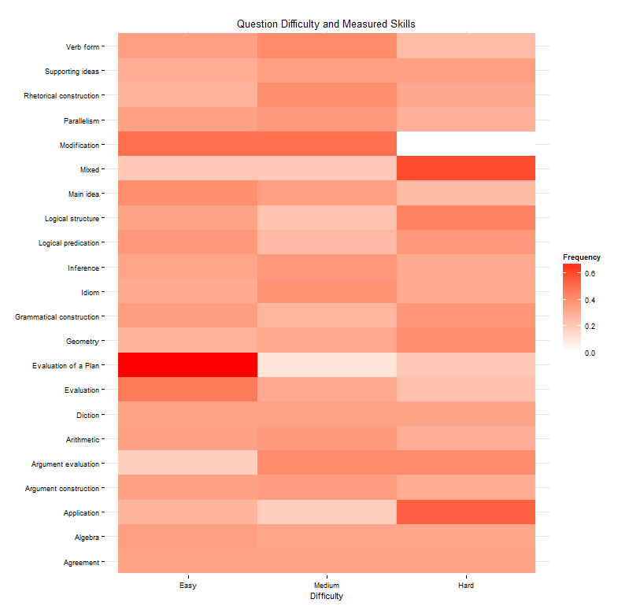

## You can use ggplot in python too

[Yhat](https://github.com/yhat/ggplot)

## Where to find examples

* Books:  
  1.R Graphics Cookbook  
  2.ggplot2: Elegant Graphics for Data Analysis
* Documentation: <http://docs.ggplot2.org/current/>
* CheatSheet: In our google drive